

**Subject: “ Fundamental of programming”**

**Name: M.Yahya Chand**

**Roll#: 456727**

**Section: ME-15 B**

**Submitted to: SIR. Affan**

**DATE: 27 OCT,2023**

**Lab task #1:**

**#include <iostream>**

**using namespace std;**

**int main() {**

**int x=1;**

**do {**

**cout<<"enter a number " << endl;**

**cin>>x;**

**}**

**while (x>0) ;**

**return 0;**

**}**

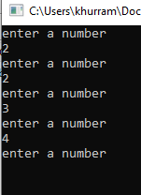

**Lask task#2:**

**#include <iostream>**

**#include<math.h>**

**using namespace std;**

**int main() {**

**int x, y , Ans=0 ,i;**

**char operation;**

**do {**

**cout<<"Enter first number :";**

**cin>>x;**

**cout<<"Enter second number :";**

**cin>>y;**

**cout<<"Enter the operation :";**

**cin>>operation;**

**switch (operation) {**

**case '+':**

**Ans=x+y;**

**break;**

**case '-':**

**Ans=x-y;**

**break;**

**case '*':**

**Ans=x*y;**

**break;**

**case '/':**

**if (y==0) {**

**cout<<"Your denominator is invalid at this place"<<endl; }**

**Ans=x/y;**

**break;**

**case '%':**

**if (y==0) {**

**cout<<"your second number is invalid”<<endl; }**

**Ans=x%y;**

**break;**

**case '^':**

**Ans=pow(x,y);**

**default:**

**cout<<" ENTERED operation is invalid try again"<<endl; }**

**cout<<Ans <<endl;**

**cout<<"press 1 to continue and 0 for termination"<<endl;**

**cin>>i; }**

**while (i==1);**

**return 0;}**

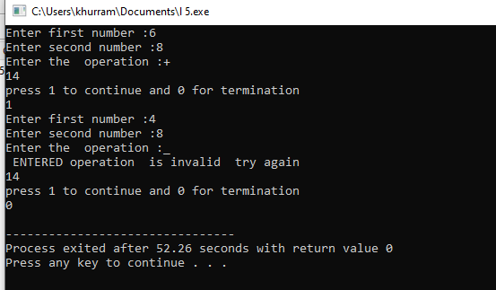

**Lab task# 3(a):**

**#include <iostream>**

**#include<math.h>**

**using namespace std;**

**int main() {**

**int a=2,sum=0;**

**while (a<=100) {**

**if (a%2==0) {**

**sum =sum+a;**

**}**

**a++; }**

**cout<<sum<<endl;**

**return 0;**

**}**

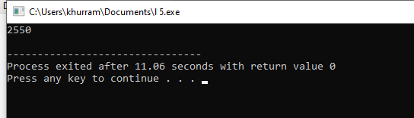

**Lab task#3(b):**

**#include <iostream>**

**#include<math.h>**

**using namespace std;**

**int main() {**

**int b=1,sum=0;**

**while (b<=100) {**

**sum=sum + b*b;**

**b++; }**

**cout<<sum<<endl;**

**return 0;**

**}**

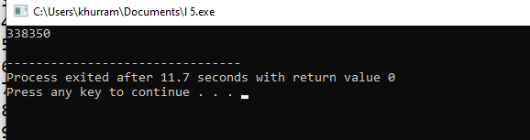

**Lab task# 4(a):**

**#include <iostream>**

**#include<math.h>**

**using namespace std;**

**int main() {**

**int x=0;**

**while (x<=20) {**

**cout<<pow(2,x)<<endl;**

**x++; }**

**return 0;**

**}**

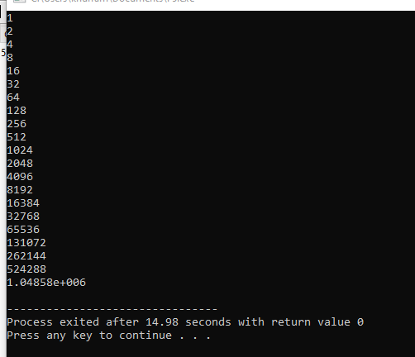

**Lab task3 4(b):**

**#include <iostream>**

**#include<math.h>**

**using namespace std;**

**int main() {**

**int a,b , sum=0 ;**

**cout<<"enter 1st number"<<endl;**

**cin>>a;**

**cout<<"enter 2nd number"<<endl;**

**cin>>b;**

**while (a<=b ) {**

**if (a%2==1 ) {**

**sum=sum+a;**

**}**

**a++;**

**}**

**cout<<sum<<endl;**

**return 0;**

**}**

